What Tatting, an old handcrafts for creative ideas of today

Exhibition, selling and instructions for:
- Classical Tatting

Needle Tatting
- Creative Tatting
- Tatting Individual
- Accessories
When September 24, 2016
14 o’clock Opening of the exhibition (subject to alterations)

14:30 o’clock Course Classical Tatting for new fans
Tutor: n.d.
15:00 o’clock Initial training for Creative Tatting
Tutor: Edith Roesti
15:30 o’clock Seminar Needle Tatting
Tutor: n.d
Workshops presented by Occhi-Freunde Oberschwaben:
- Origami boxes – useful for tatting handworks
- Tatting trifles to learn about and / or to decorate the boxes

18 o’clock Exhibition closing (for today)

19 o’clock Get together of all tatters:
- Common dinner with local kitchen
- Discussion, gossip, tattling (but also professional news)

September 25, 2016
10 o'clock Exhibitor meeting (guests are welcome)
11 o’clock Opening of the exhibition

11 o’clock Course Classical Tatting for new fans
Tutor: n.d.
13 o’clock Initial training for Creative Tatting
Tutor: Edith Roesti
14 o’clock Seminar Needle Tatting
Tutor: n.d.
Workshops presented by Occhi-Freunde Oberschwaben:
- Origami boxes – useful for tatting handworks
- Tatting trifles to learn about and / or to decorate the boxes

17 o’clock End of the exhibition (but just for this year)
Where Ballroom of the Illenau
Illenauer Allee
77855 Achern / Germany
How much visitors € 3,--
exhibitors € 30,--
Contact E-Mail: ausstellung@occhi.de
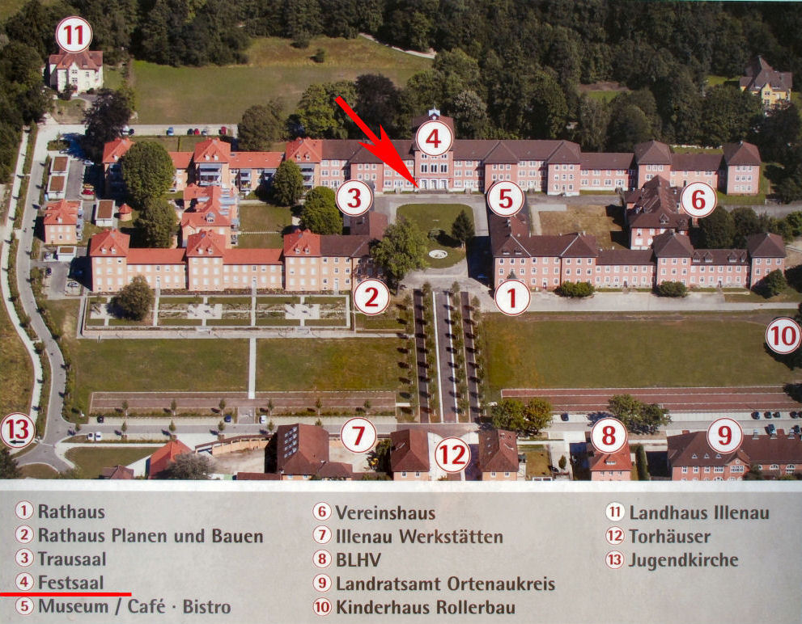

The tatting exhibition will take place in the ballroom of the central building.
Illenauer Allee - 77855 Achern
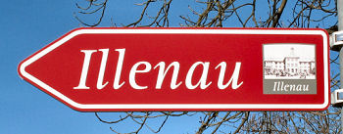

Within the city Achern the Illenau
is signposted with red / brown signs

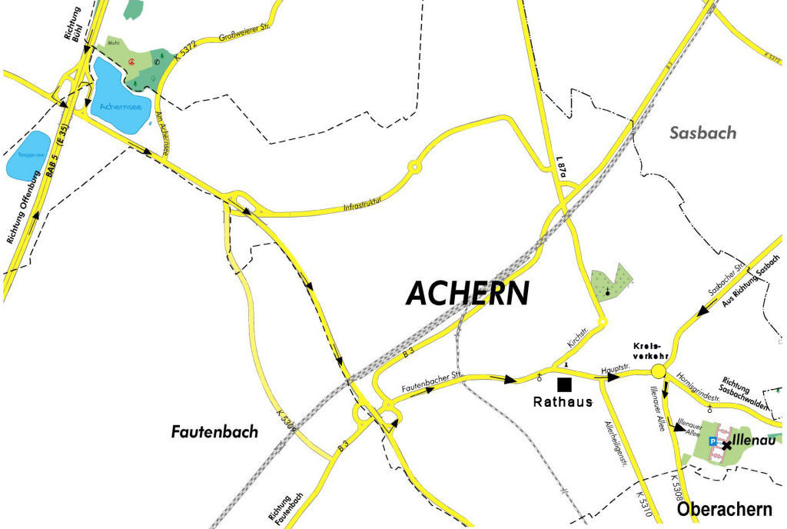

Registration Form for Achern
Conditions:
Exhibition stand per registration: 1,4 x 0,7 m table. Selling of exhibits is permitted

Registration fee: € 30,-- per registration. Additional tables: € 15,-- each

Deadline for registration: 30.08.2016

Herewith I register for the tatting exhibition at Achern in Germany, dated 24th and 25^{h} of September 2016:

First and sec. name:

Street / No.

ZIP-Code / City:

Country:

Phone:

Fax:

E-Mail:

The following exhibits I intend to present:

I need additional tables. Number of additional tables :

I agree that my data will be published on the Internet www.landkarte.occhi.de,

Exhibition fees I transfer to:

Account holder: Rolf Kellner
Name of bank: Sparkasse Achern BLZ: 664 500 50 Account No. 975 592
SWIFT-BIC.: SOLADES1OFG IBAN: DE97 6645 0050 0000 9755 92

This registration form should be posted to the organizer:

